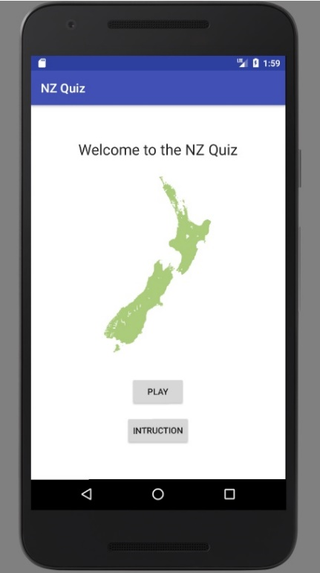

Welcome Screen

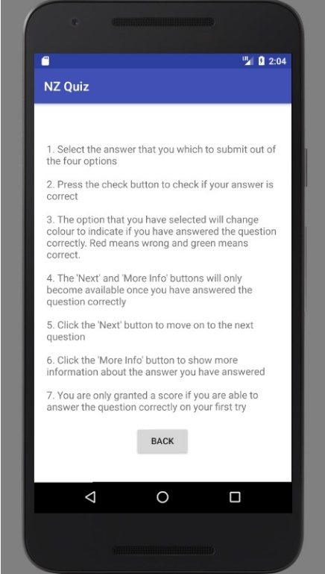

Instruction Screen

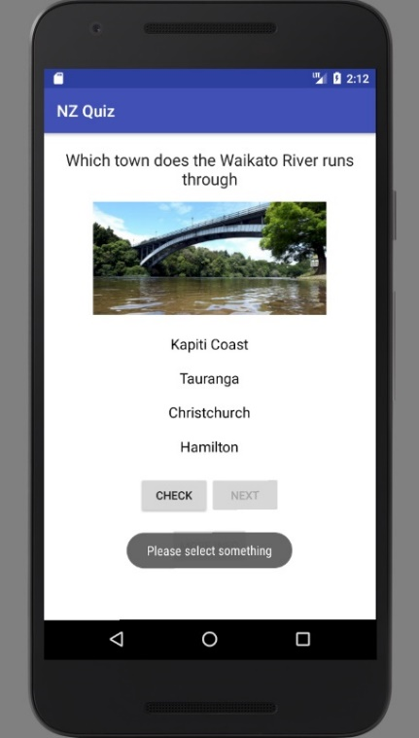

No Selection Screen

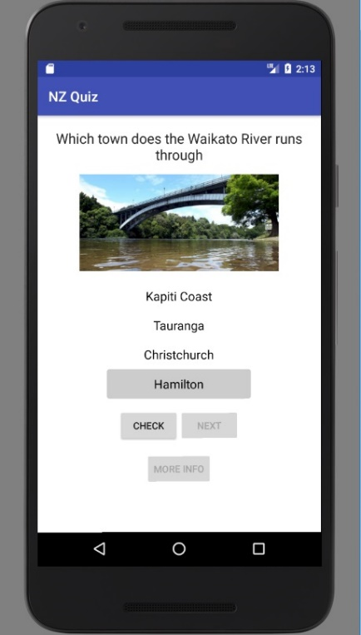

Selected Screen

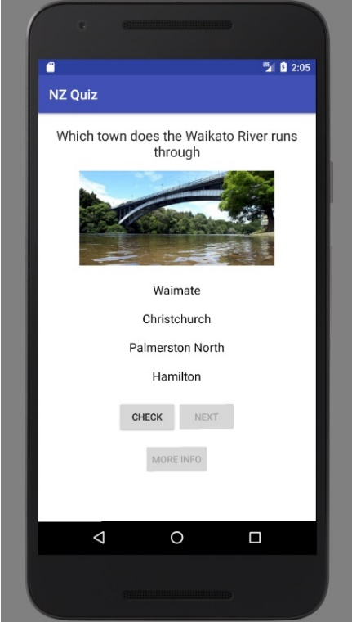

Question Screen

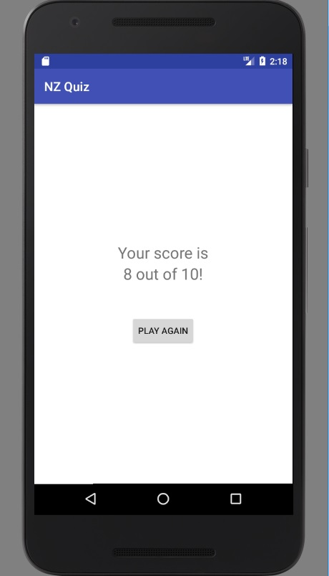

Final Score Screen

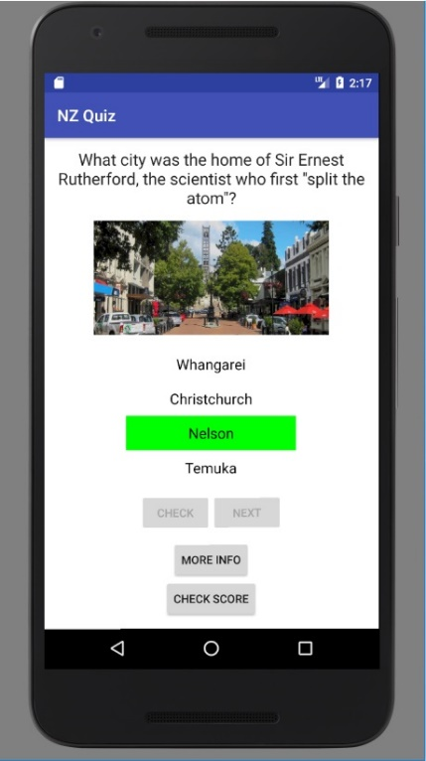

Last Question Screen

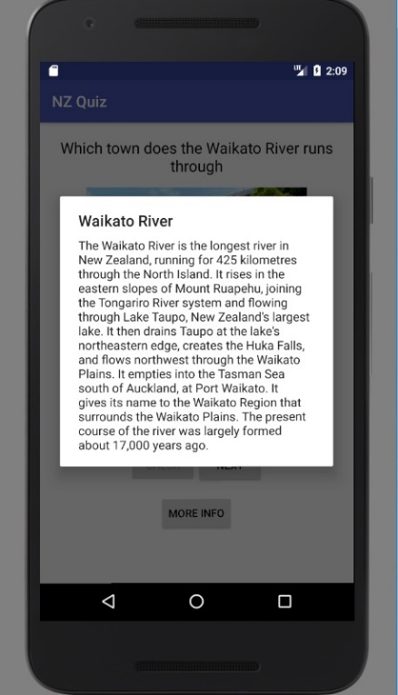

More Info Screen

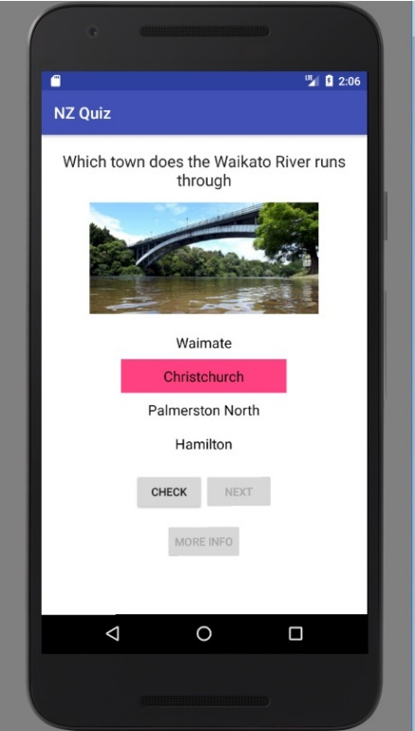

Wrong Answer Screen

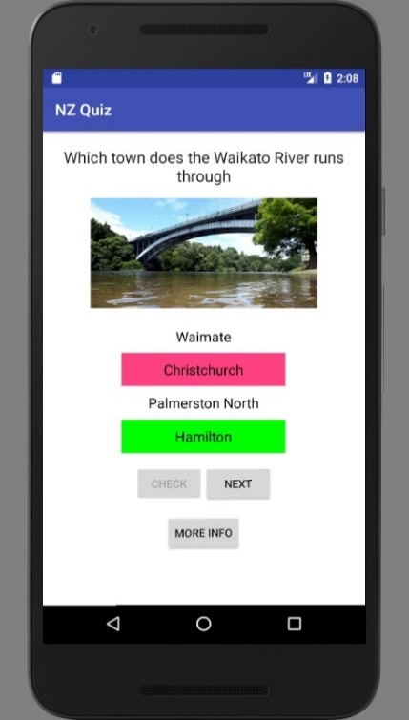

Correct Answer Screen Screen

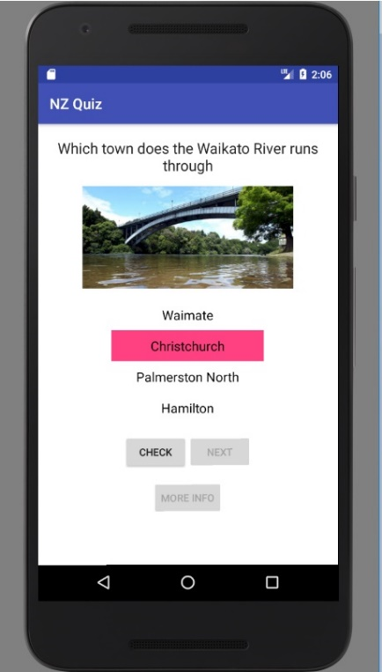

Wrong Answer Screen

1. Radio button redesign to look like a normal button for ease of selecting

Instruction Screen

2. Large text for ease of reading on phone screens

3. Large images for ease of viewing on phone screens

4. Button colour change for question feedback instead of toast to making it easier to identify if the answer was correct

5. Clean solid colour background

6. Dialog box for more information prompt which is bigger than toast prompts for ease of viewing on mobile screens